Advanced Soil Organic Matter Chemistry
Lecture 1:
- definition Soil Organic Matter SOM
Soil Organic Matter can be define as fellow:
1- it is amaterial of high molelucalar weights for example , proteins and polysaccharides
2 - simple saccharides with low molelucalar weights as amino acides
3- humic substances or nonhumic substances
AS, figure below organic soil substances can be classified to
Main kinds firstly , microorganisms (biota ) secondly , entirely or partially composed substances and non decomposed substances with transformed (humus) or non transformed products as fallen leaf.
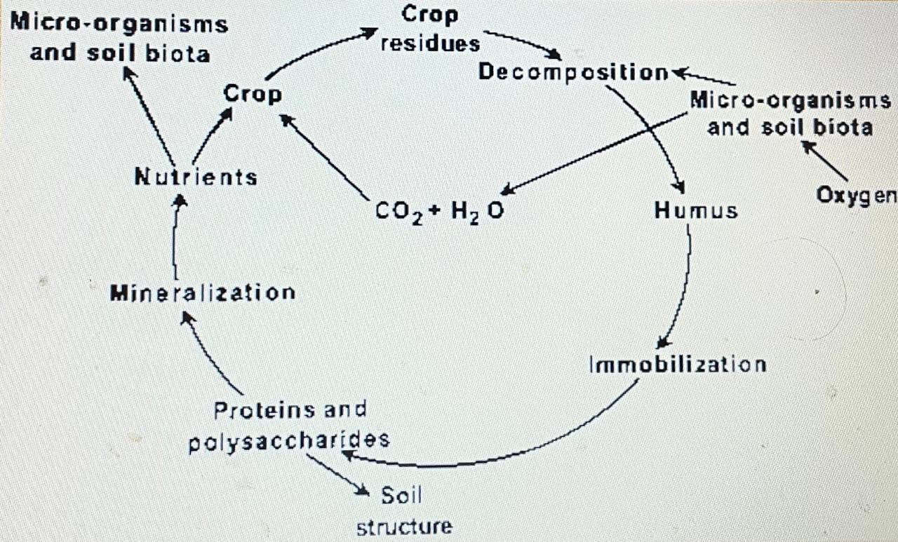
Functions of organic matter in soil
Three main Functions of SOM :
Firstly , SOM is a source of macro as N and P( as organic companents in nature ) but K ( it is salts in nature ).
Secondly , SOM has role in microbiology activity in nature
Thirdly , SOM affects in chemi- physical and biological
Soil properties as moisture, aeration , CEC , then soil aggregates and downward water and roots elongation and plants .
Forth , decomposed or non decomposed manure SOM can be as a source of demanded energy to microorgansims .

Q: micro-organisms and soil biota at absent or present oxygen can decompose Humus by main groups processes to release simple compounds , explain these processes with an essential products , (answer with points) ?

ا

